1. **GET Request(** [**http://127.0.0.1:5000/employee**](http://127.0.0.1:5000/employee) **)**

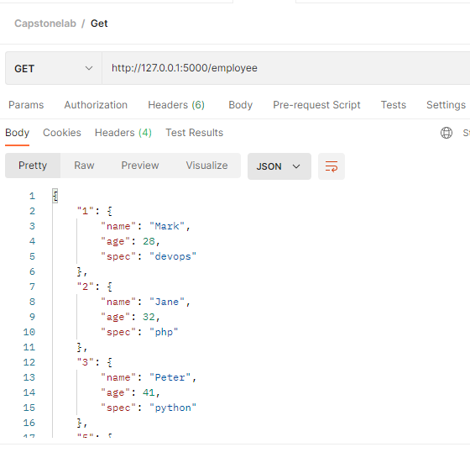

2**. Post (http://127.0.0.1:5000/employee?name=Sumit&age=35&spec=devops)**

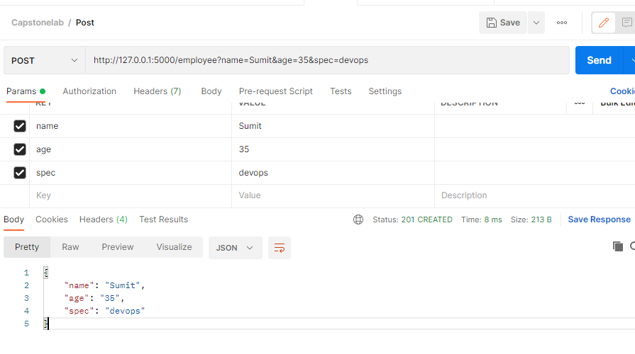

1. **PUT (**[**http://127.0.0.1:5000/employee/7?name=Amit&age=40&spec=None**](http://127.0.0.1:5000/employee/7?name=Amit&age=40&spec=None)**) and Get post Editing value**

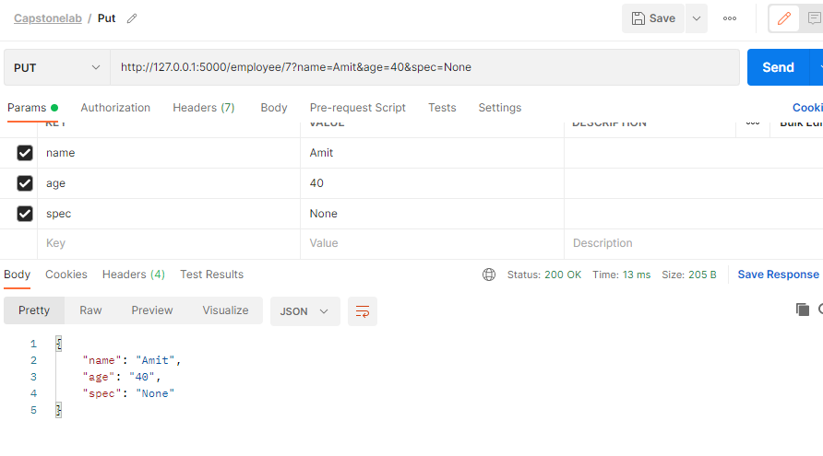

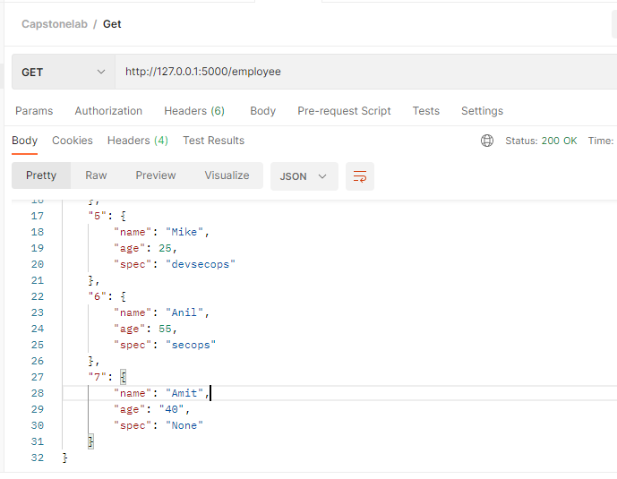

1. Delete (<http://127.0.0.1:5000/employee/7>) and Get Result post deleting

